DECISIONS DELEGATED TO OFFICERS

Decision title: | Entering into a funding agreement to provide grant for the provision of affordable housing under the Oxfordshire Housing and Growth Deal to A2 Dominion Housing Group with respect to the Gibbs Crescent development.
Decision date: | 4 January 2022
Source of delegation: | Cabinet on 14 October 2020 resolved to:  1. Give project approval to the proposals, to accept and distribute grant; enter  into funding agreements; and any other necessary agreements or contracts,  as set out in this report for sites at William Morris Close; Gibbs Crescent; and  Champion Way, for the purpose of delivering more affordable housing in  Oxford, through the Oxfordshire Housing and Growth Deal programme;  3. Note that the budget for further Growth Deal grant payments will be  requested in future budget reports;  4. Delegate authority to the Director of Housing, in consultation with the  Cabinet Member for Affordable Housing; the Head of Financial  Services/Section 151 Officer; and the Council’s Monitoring Officer, to enter  into funding and other necessary agreements for the purpose of delivery  affordable housing through the Oxfordshire Housing and Growth Deal programme, within identified budgets, for the schemes listed in this report.  The budget was subsequently provided in budget reports, the most recent change receiving approval by Council in July 2021, which allocated £330,000 for this purpose.
What decision was made? | To enter into a funding agreement to provide grant for the provision of affordable housing under the Oxfordshire Housing and Growth Deal to A2 Dominion Housing Group with respect to the Gibbs Crescent development.
Purpose: | Agreement to provide grant funding to support this development
Reasons: | The conditions for the release of 90% of the funding is expected to be met in Quarter 4 2021/22 as the development contract is awarded. The remaining grant is to be paid on completion.
Decision made by: | Stephen Gabriel, Executive Director – Communities and People  Decision taken in consultation with:  Cllr Diko Walcott (nee Blackings), Cabinet Member for Affordable housing, Housing Security and Housing the Homeless.  Nigel Kennedy, Head of Financial Services  Susan Sale, Head of Law & Governance
Other options considered: List any alternatives that were available to the decision taker and why they were rejected | To not provide a grant – this option was rejected as it would not support the delivery of the Oxfordshire Housing & Growth Deal
Documents considered: Please attach any new documents relevant to the decision and state if they are exempt | Project Approval and Allocation of Housing and Growth Deal Funding for Affordable Housing Delivery report to Cabinet on 14 October 2020
Key or Not Key: (see notes below): | Not Key
Wards significantly affected: If 2+ wards are significantly affected this will need to be treated as a key decision (see notes below) | None
Declared conflict of interest: Please record any declared conflict of interest by any Cabinet Member consulted on the decision which relates to the decision. | None
This form was completed by:  Name & title:  Date: | Dave Scholes  Affordable Housing Supply Corporate Lead  31 December 2021

Approval checklist

Approver | Name and job title | Date
Decision Maker | Stephen Gabriel, Executive Director – Communities and People  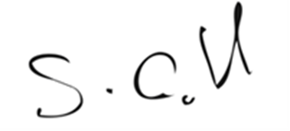 | 4 January 2022

Consultee Checklist

Head of Law and Governance | Susan Sale, Head of Law and Governance  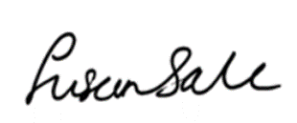 | 4 January 2022
Head of Financial Services | Nigel Kennedy, Head of Financial Services  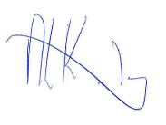 | 4 January 2022
Cabinet Member | Cllr Diko Walcott (nee Blackings), Cabinet Member for Affordable Housing, Housing Security and Housing the Homeless. | 4 January 2022

